**Descriptive Statistics – Part 2**

1. Percentiles :- The p percentile of a sample is a value such that p percentage of the values are less than or equal to this value.
2. Sort the Data
3. Compute location of p-th percentile

**Lp  = p/100 (n + 1)**

1. (If in fraction) Find Integer and Fraction Part (Ip and Fp)

**Yp = element at Ip + Fp(element at Ip+1 – element at Ip)**

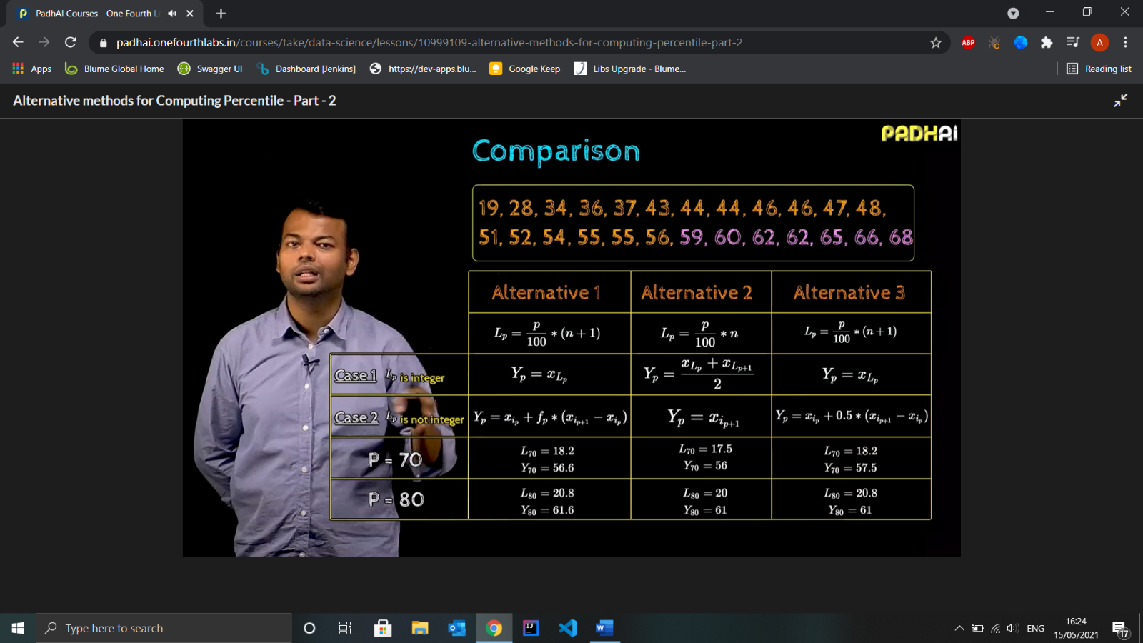

1. Quartiles :- Split the data in 4 equal parts. Median is equal to Q2
2. Quintiles :- Splits the data in 5 equal parts
3. Deciles :- Spits the data in 10 equal parts
4. Percentile Rank :- Percentage of data values that are less than or equal to it.

**PRs = 100*(cs + 0.5fs)/n**

**PRs =** percentile rank of score s

**cs =** number of values less than s

**fs =** number of values equal to s

**n =** total number of data

1. Effect of Transformation on percentiles :- Scaling and Shifting



1. Measures of Spread :- To find Variability of data
2. Range of data (max data- min data) . Not Accurate in case of Outliers
3. IQR or Inter-Quartile Range (Q3 – Q1) . Not Sensitive to Outlier
4. Variance – measure of consistency

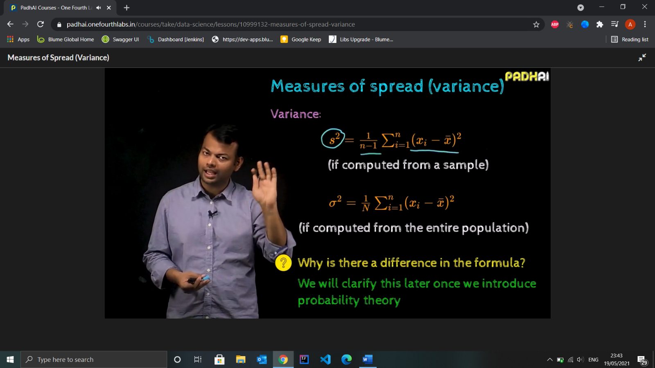

1. Standard Deviation –

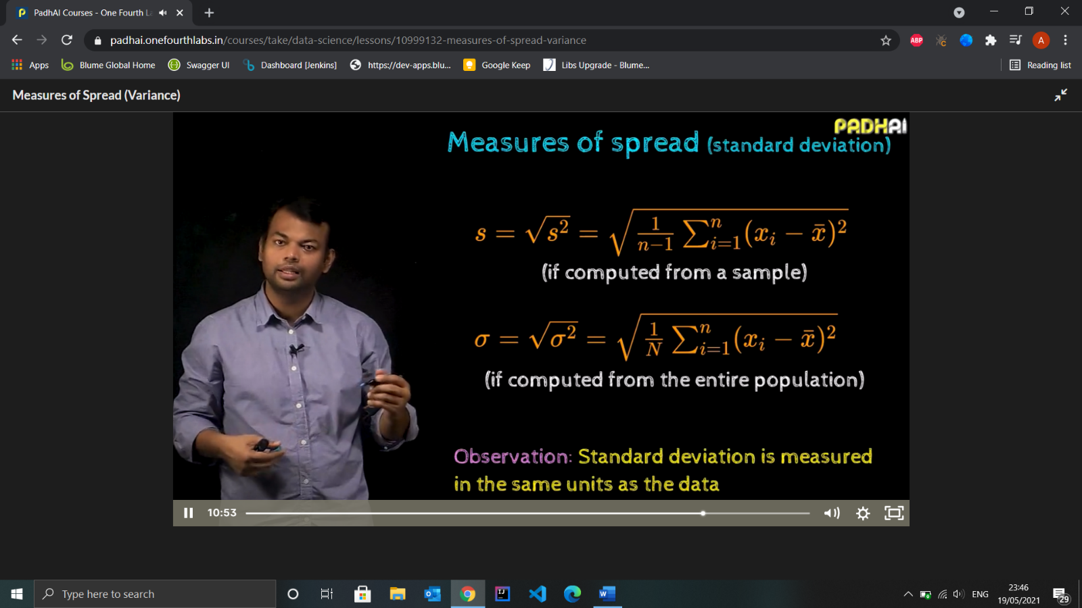

1. Effect of transformation on Measures of spread
2. Range

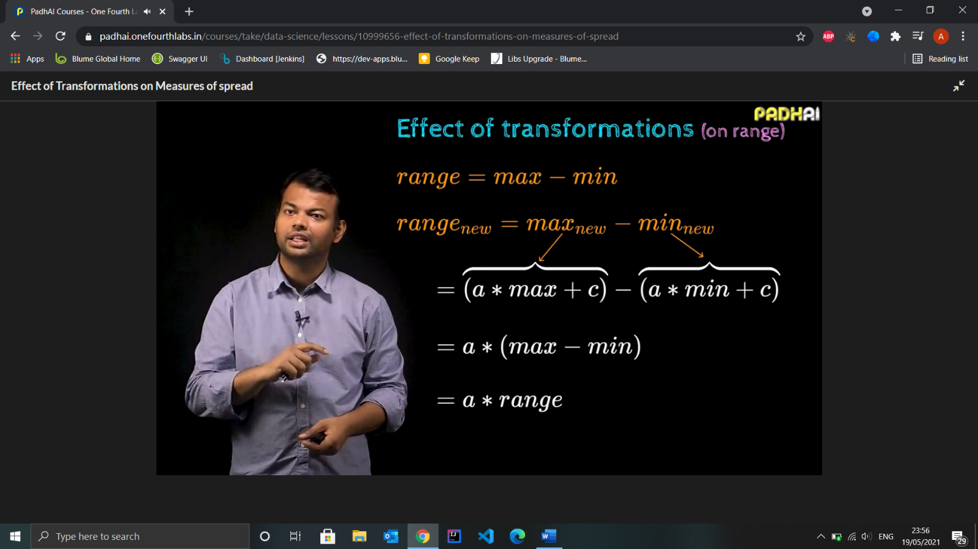

1. IQR

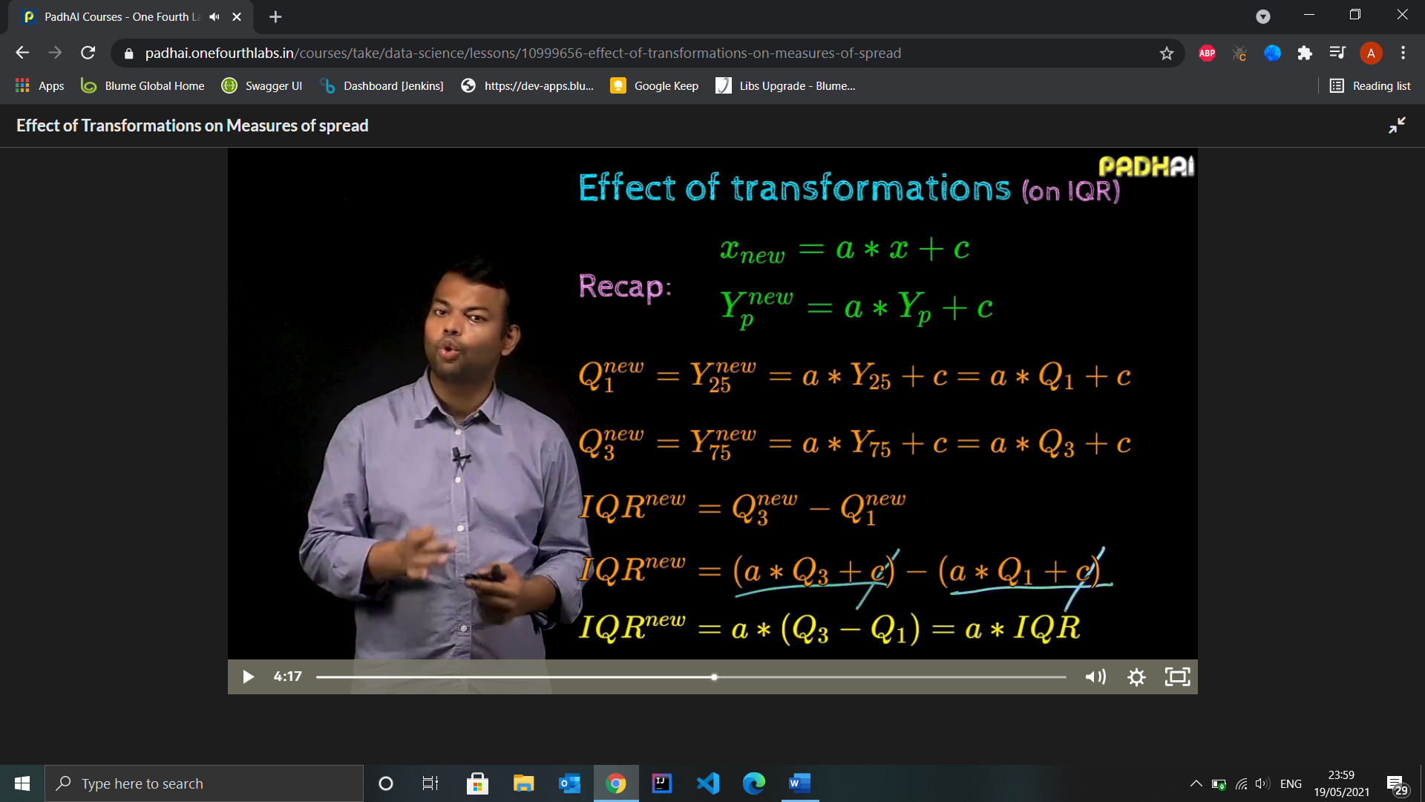

1. Variance



1. Standard Deviation

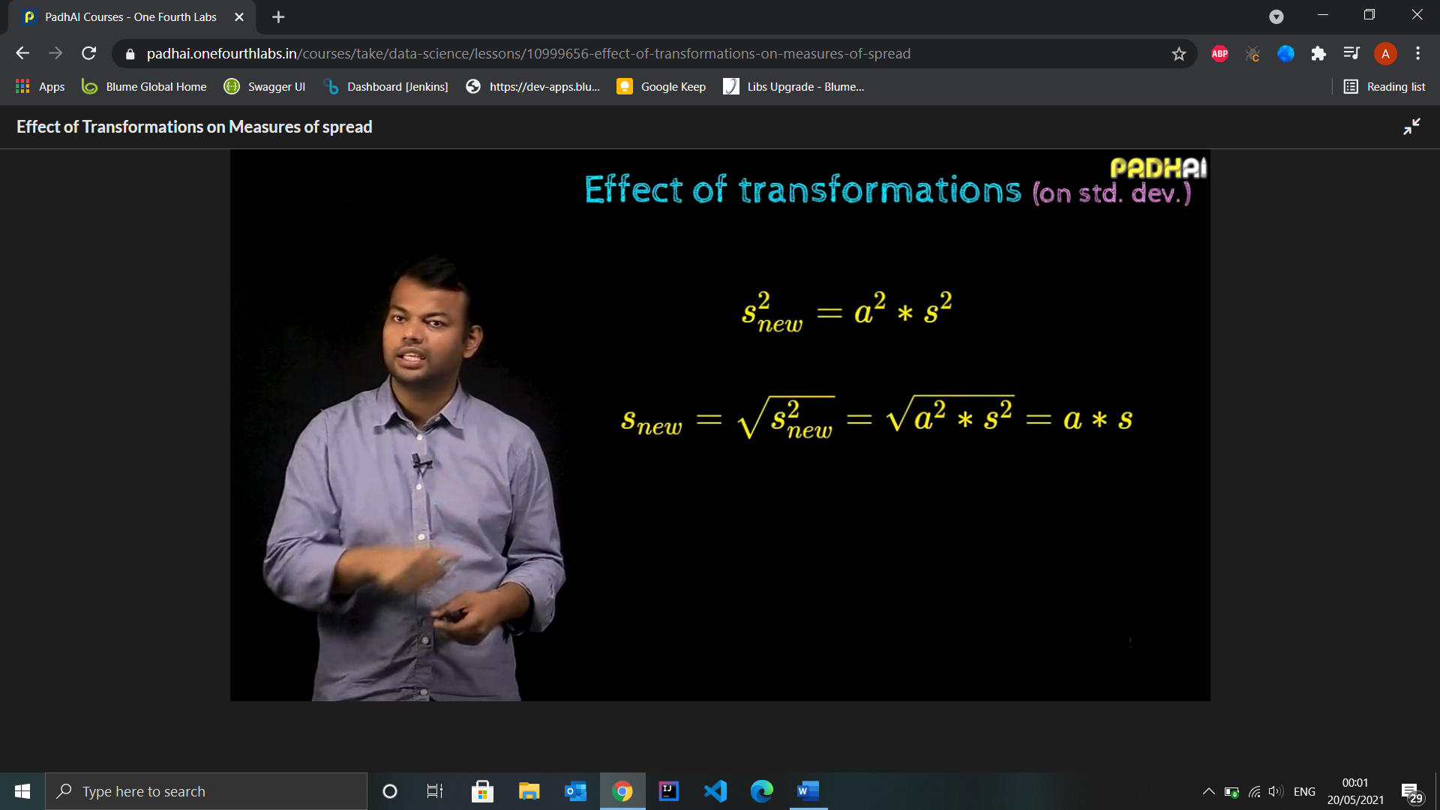

1. Standardising Data using Mean and Variance

**Xi = mean + Zi * s**

Where s = standard deviation

And Zi = (Xi -mean)/s which is Z-score of the value which tells the number of std. deviations away from mean is the value.

* Standardised data is also known as 0 mean and 1 std deviation data.
* Usage in ML :- When data’s ranges are different such as litres, feet, kgs etc we can make use of Z-scores as standard data so the data remains unbiased.

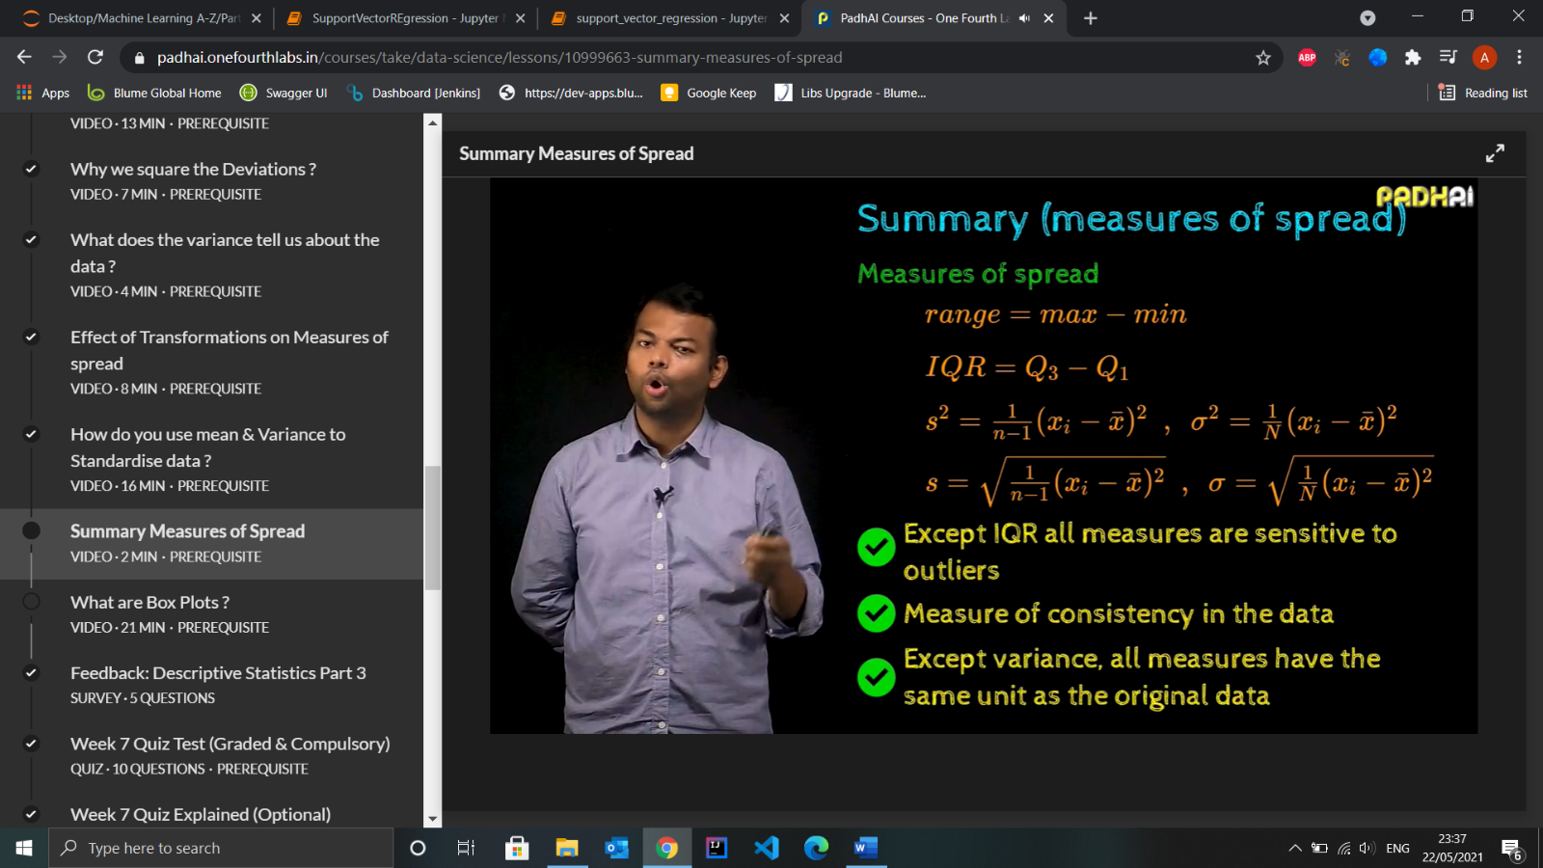

1. Box Plots

Used for visualising spread, median and outliers of the data.

* Usage in ML – It can be used to visually compare the performance of ML system
* Outliers – We say that x is in outlier if

**x < Q1 – 1.5 * IQR and x > Q3 + 1.5 * IQR**



* Different Variants of Box Plots

